**Step 1:Salesforce:**

**Activity 1: Creating Developer Account:**

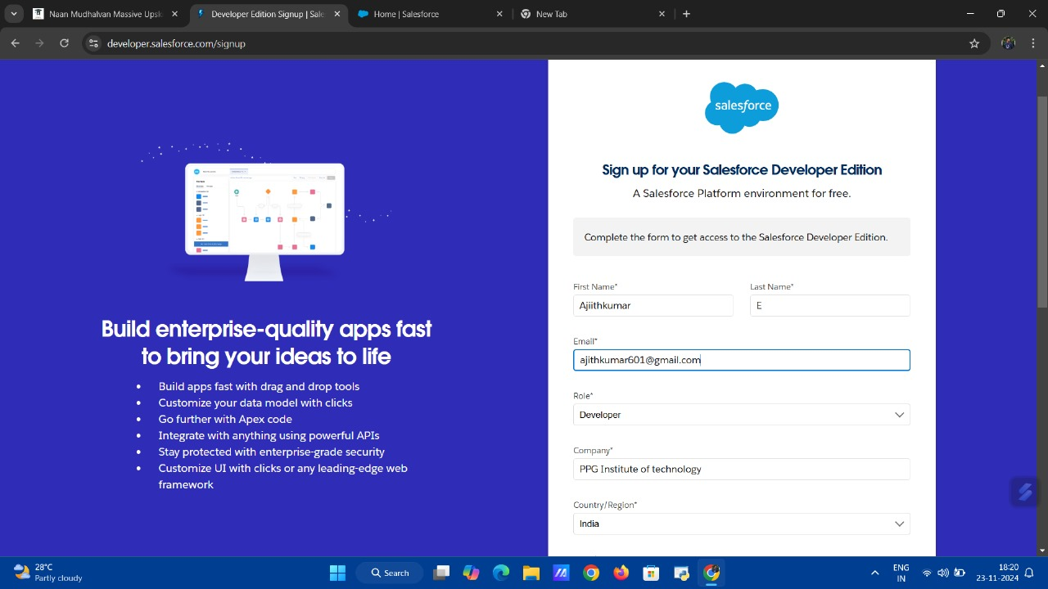

**Activity 2: Account Activation:**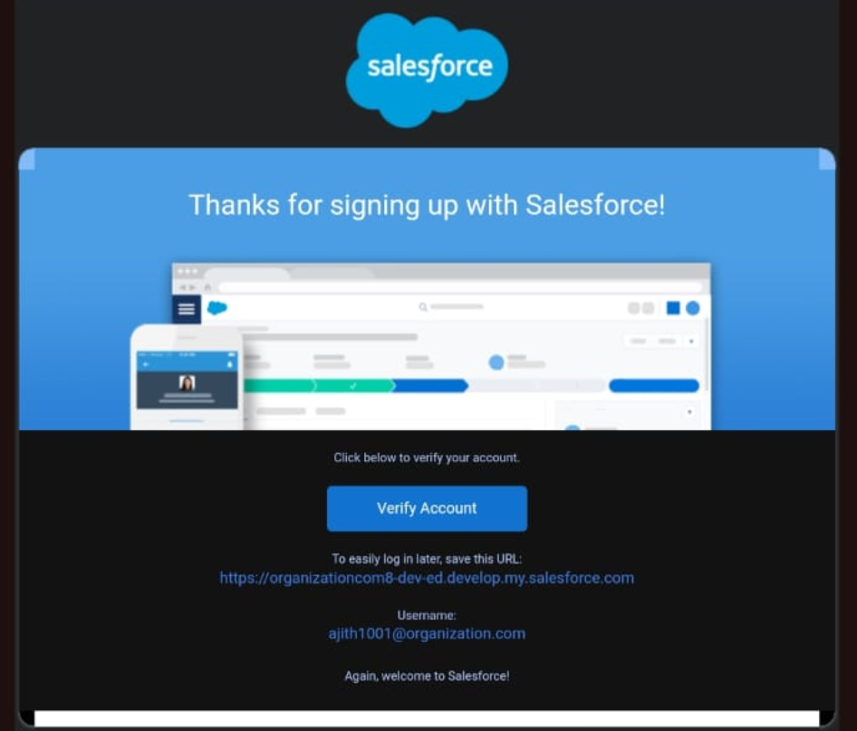

**Step 2:Objects:**

**Activity 1: Create Employee Object**

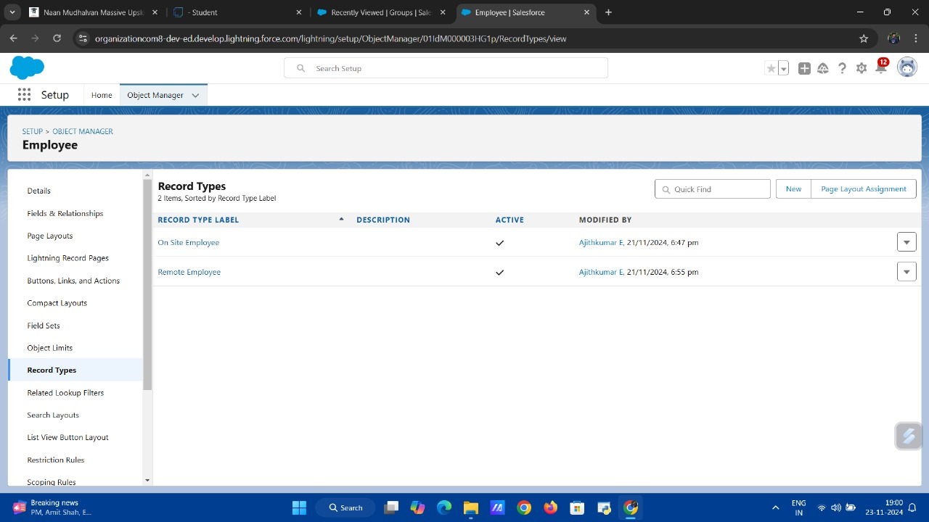

**Step 3: Tabs**

**Activity 1: Creating a Custom Tab (Employee)**



**Step 4: The Lightning App**

**Activity 1: Create a Lightning App**

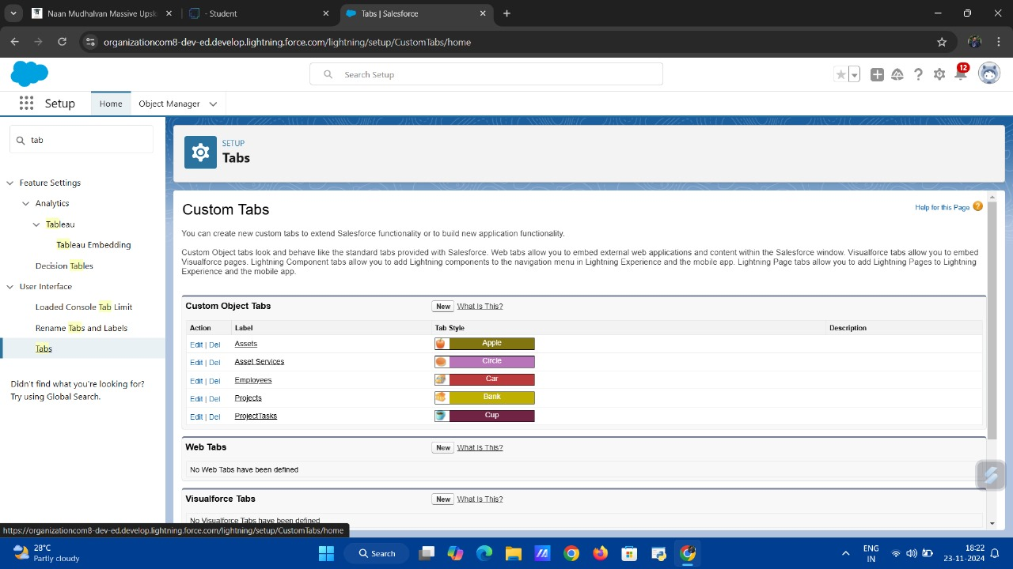

**Step 5: Fields & Relationship**

**Activity 1 : Creating Text Field in Employee Object**

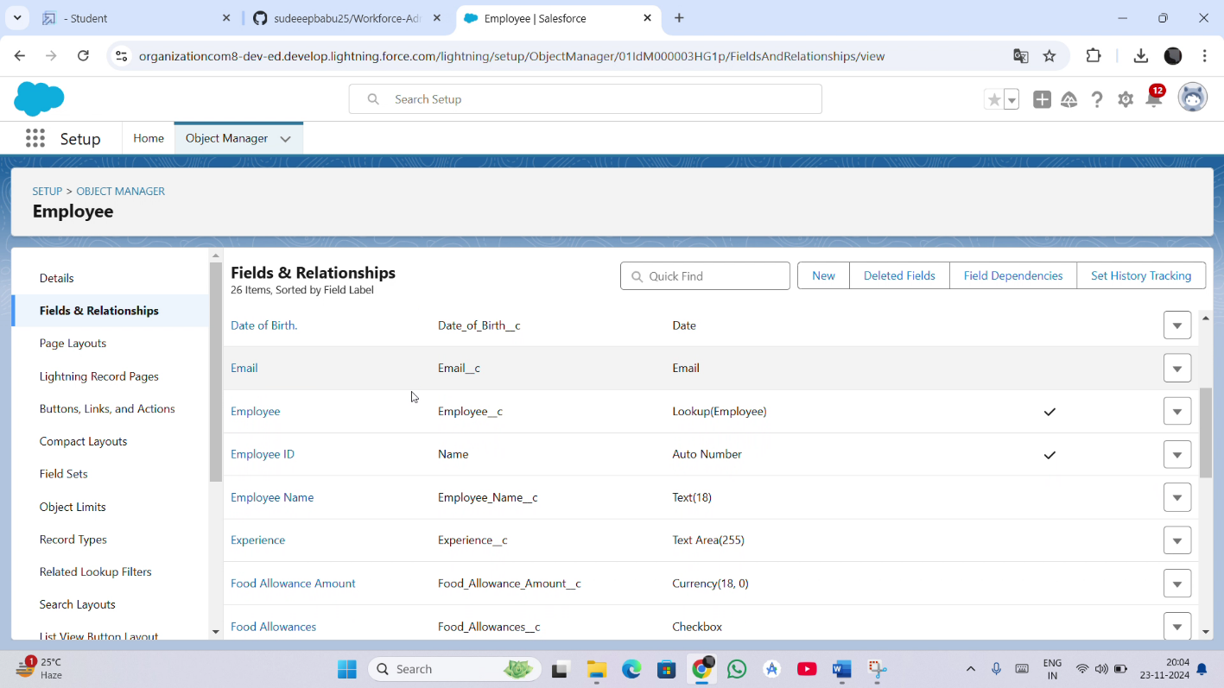

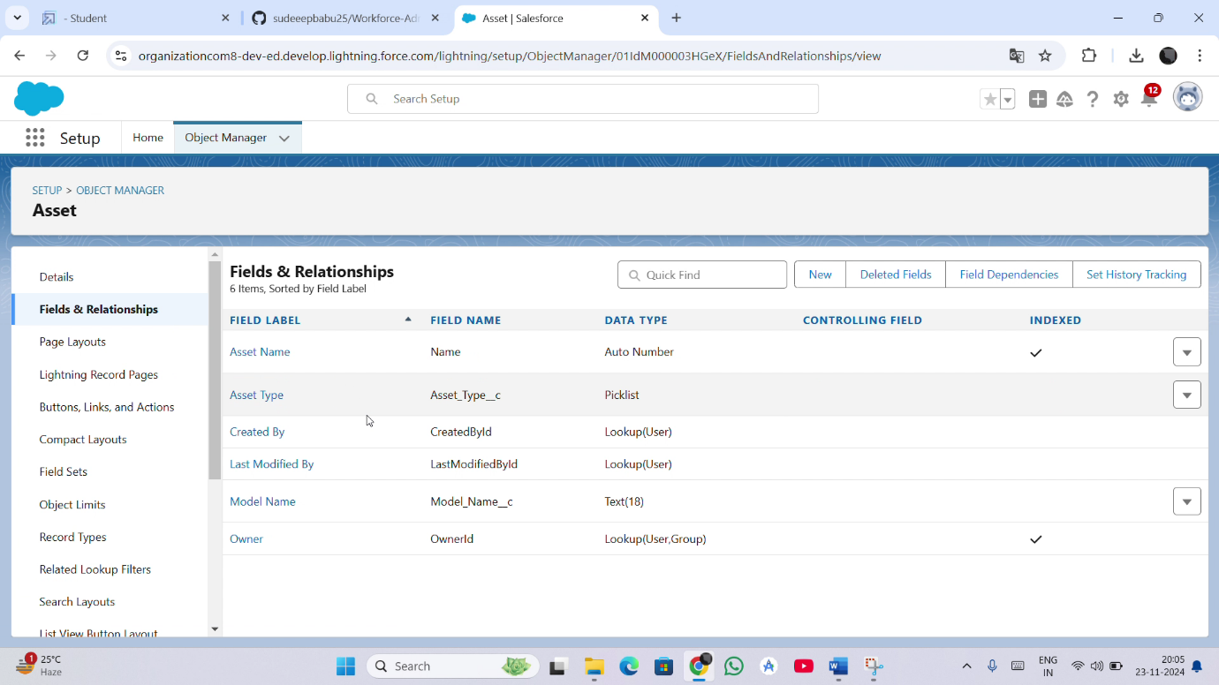

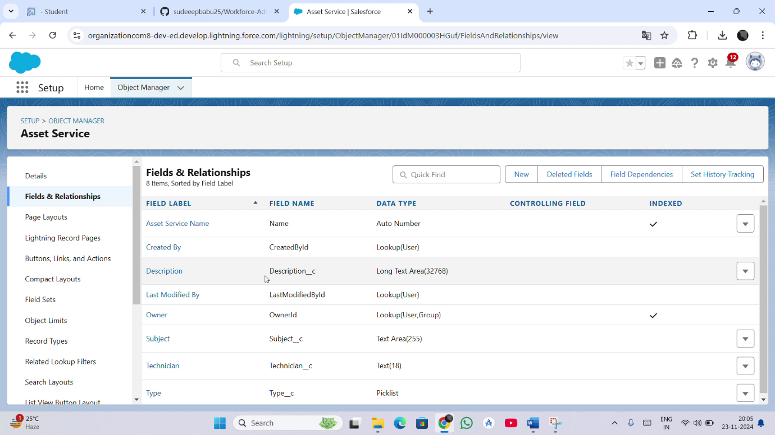

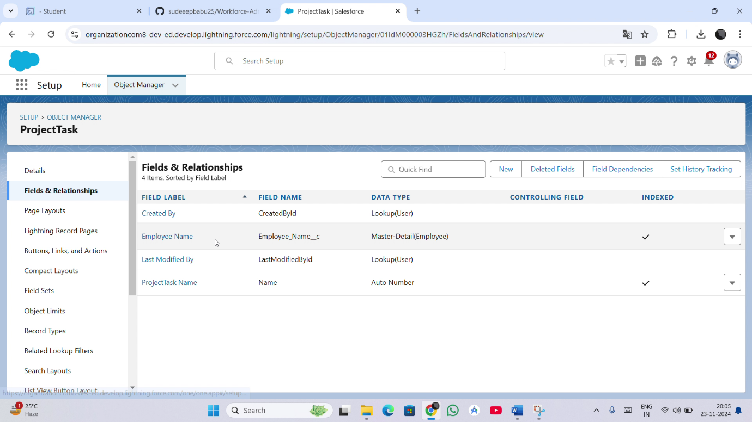

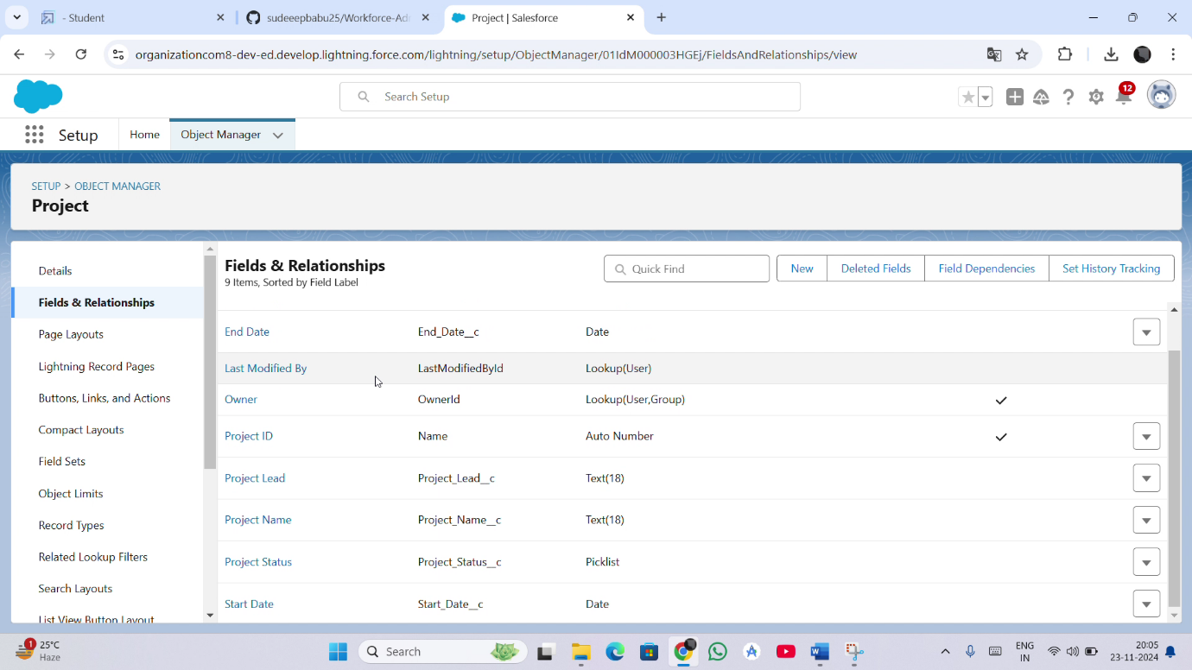

**Step 6: Setting OWD**

**Activity 1: Create OWD Setting**

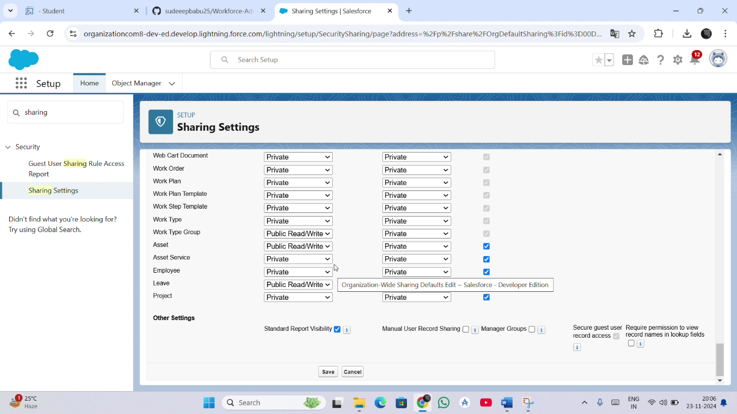

**Step 7: User Adoption**

**Activity 1: Create a Record (Employee)**

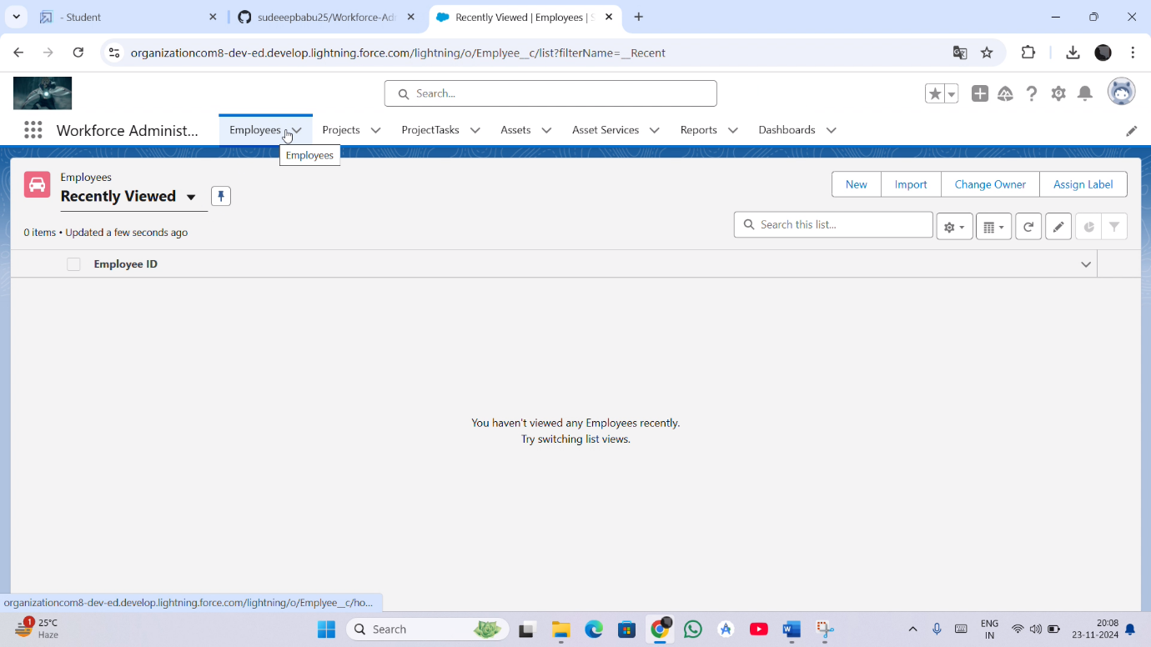

**Step 8: Import Data**

**Activity-1: Importing data using Data Wizard**

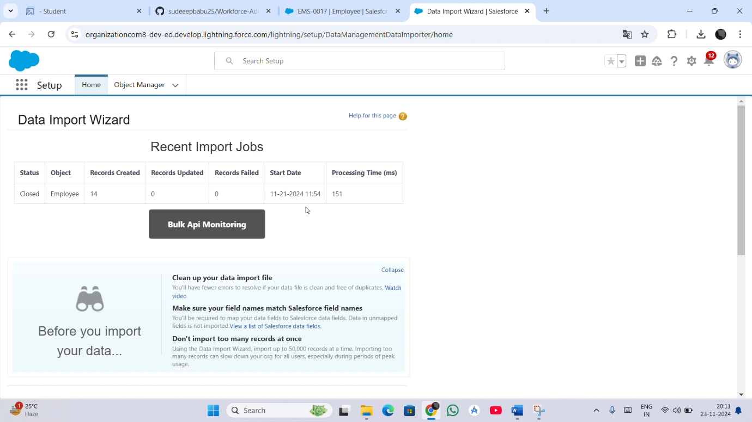

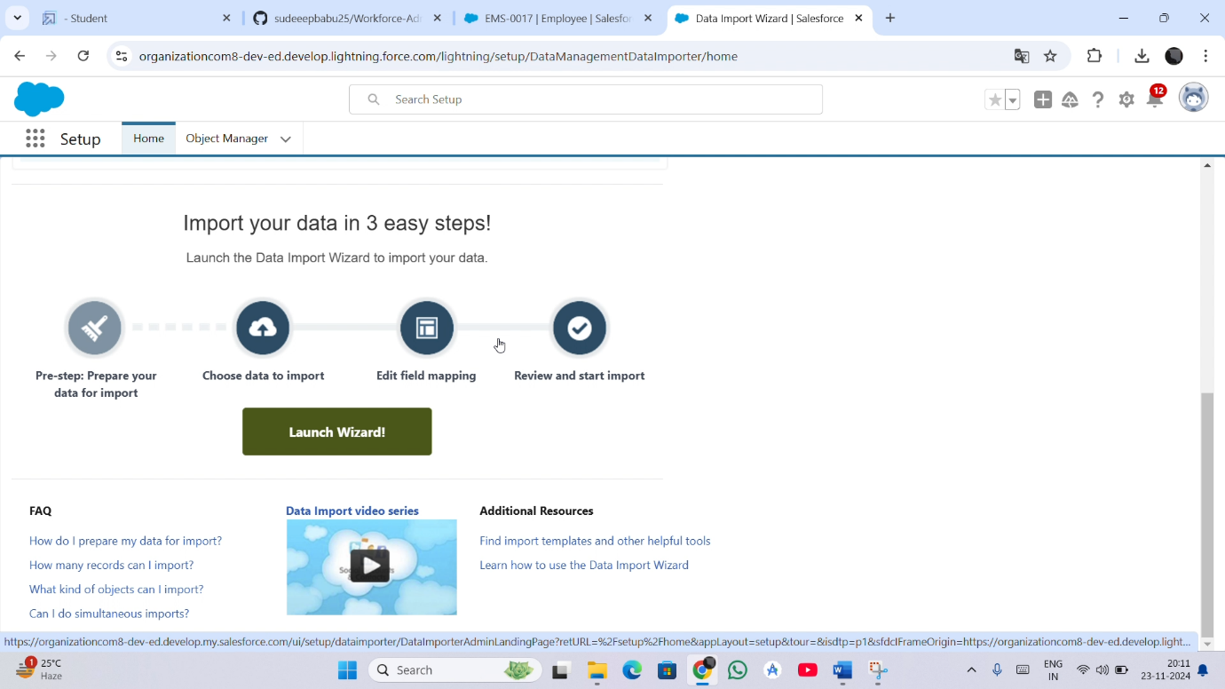

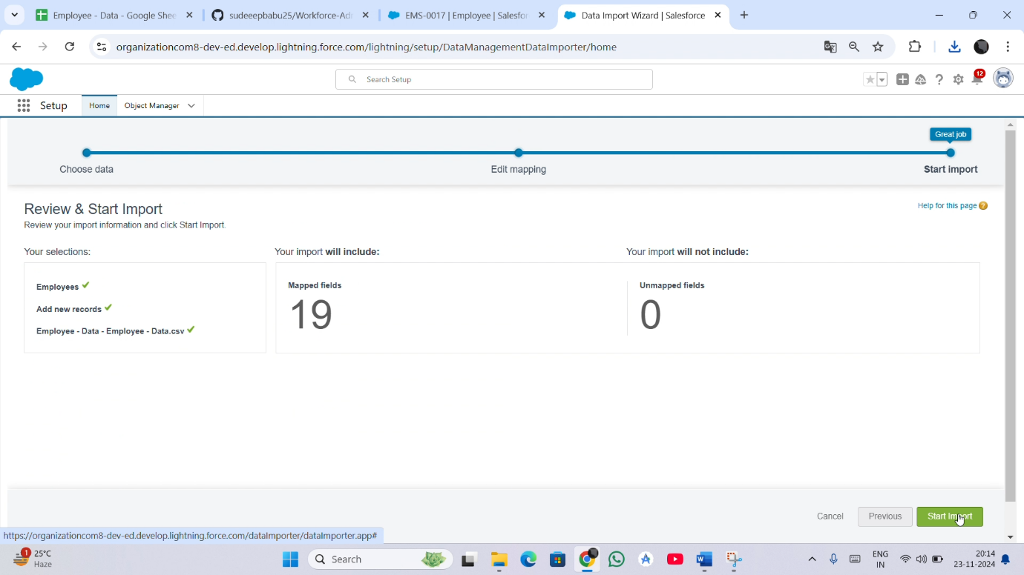

**Step 9: Profile**

**Activity 1: HR Profile , Manager Profile , Create Employee Profile**

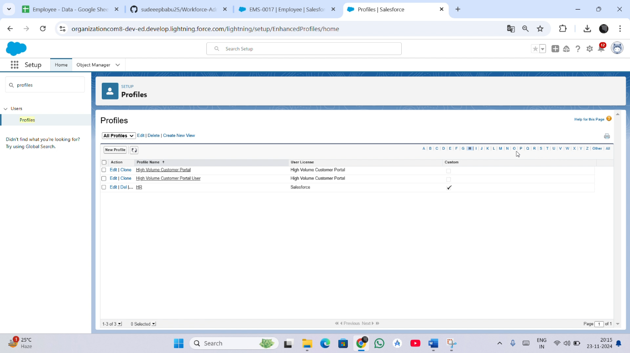

**Step 10: Roles**

**Activity 1: Creating HR Role and Creating more roles**

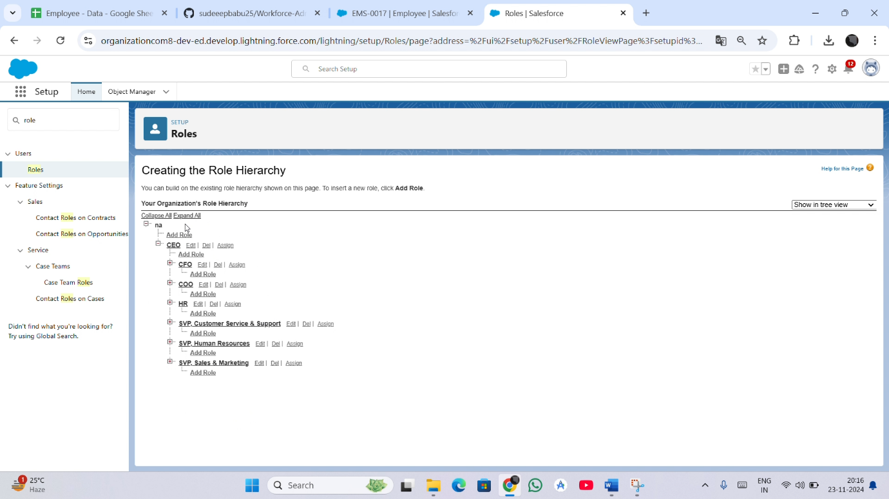

**Step 11: User**

**Activity 1: Create User**

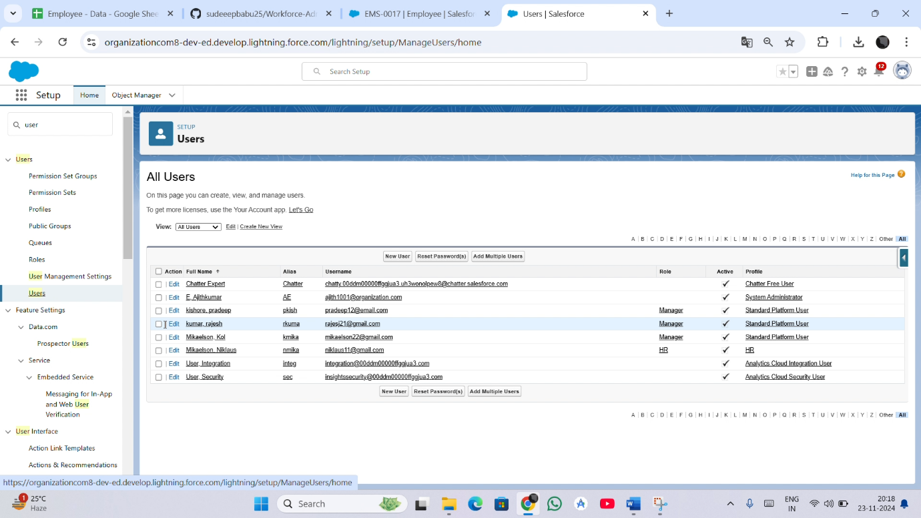

**Step 12: Page Layouts**

**Activity 1 : creating a page layout for Employee object**

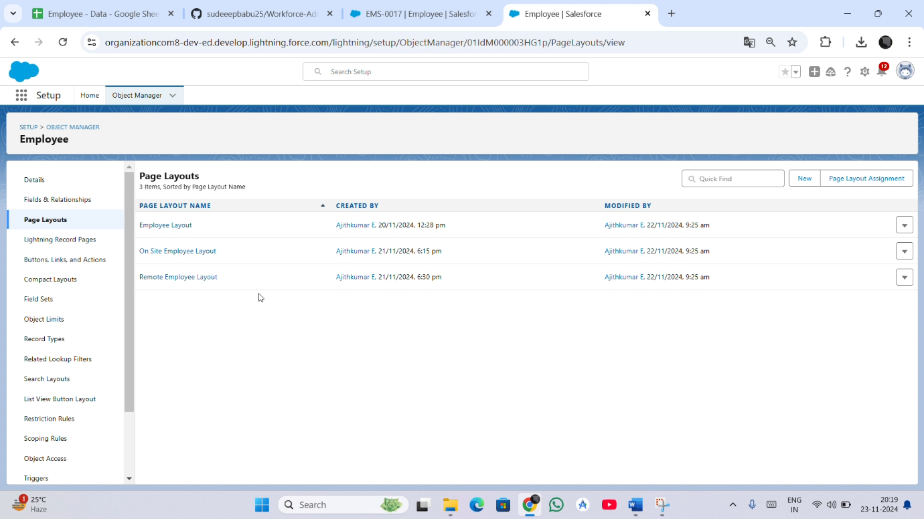

**Step 13: Chatter Group**

**Activity 1 : Creating a chatter group for your organization.**

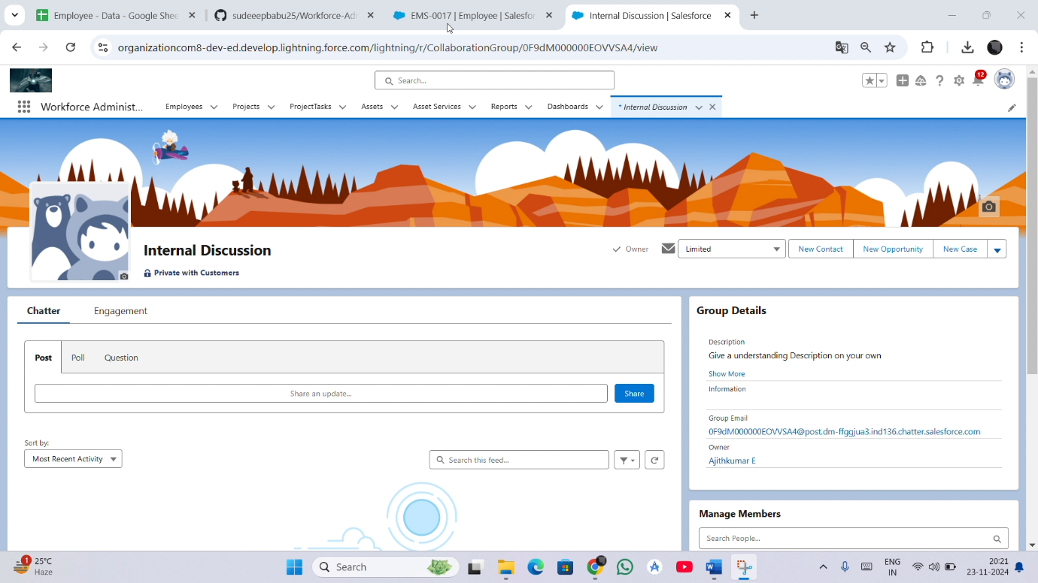

**Step 14: Record Types**

**Activity 1: Creating On Site Employee Record Type**

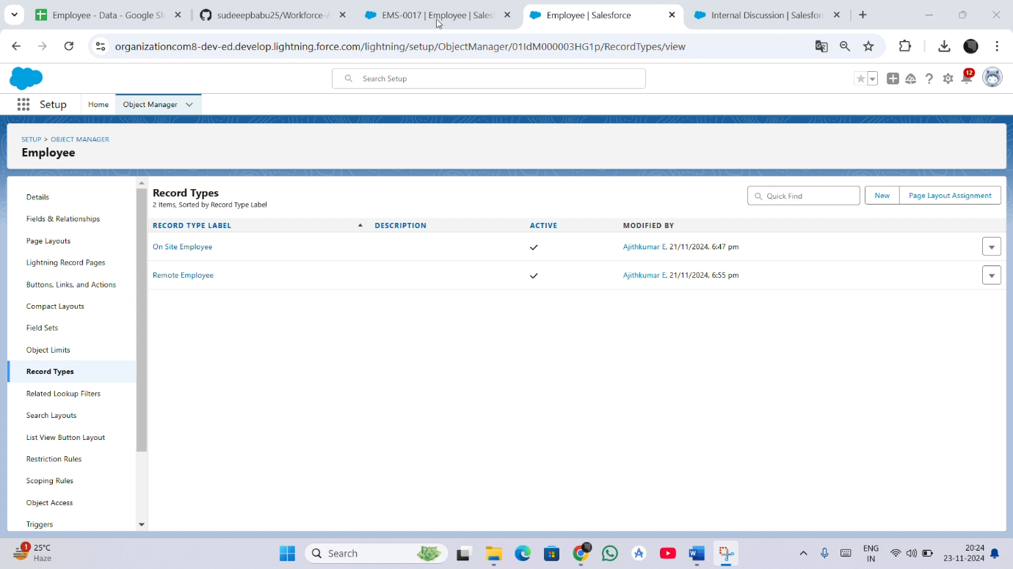

**Step 15: Permission Sets**

**Activity 1: Creating a permission set**

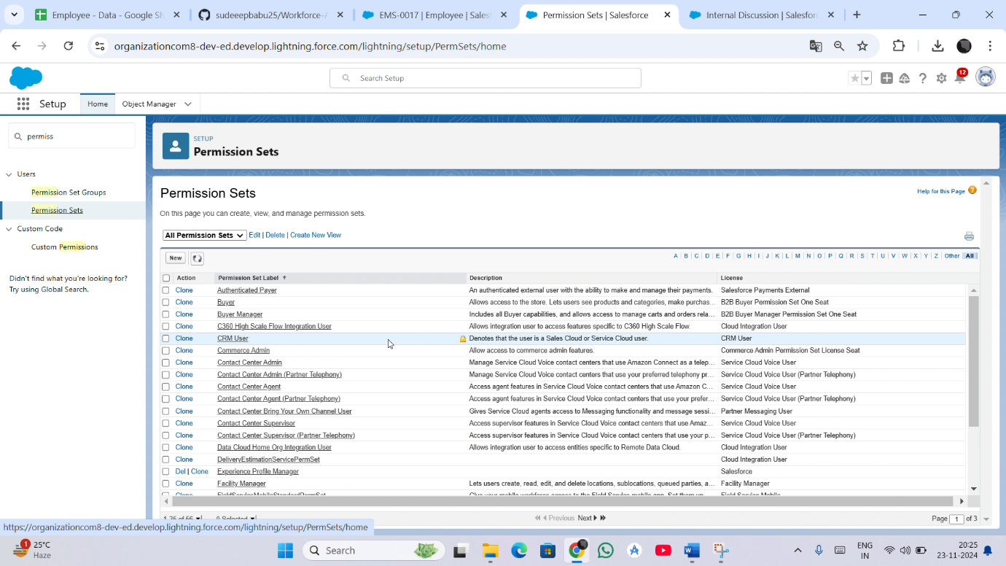

**Steps 16: Report**

**Activity 1: Create Report**

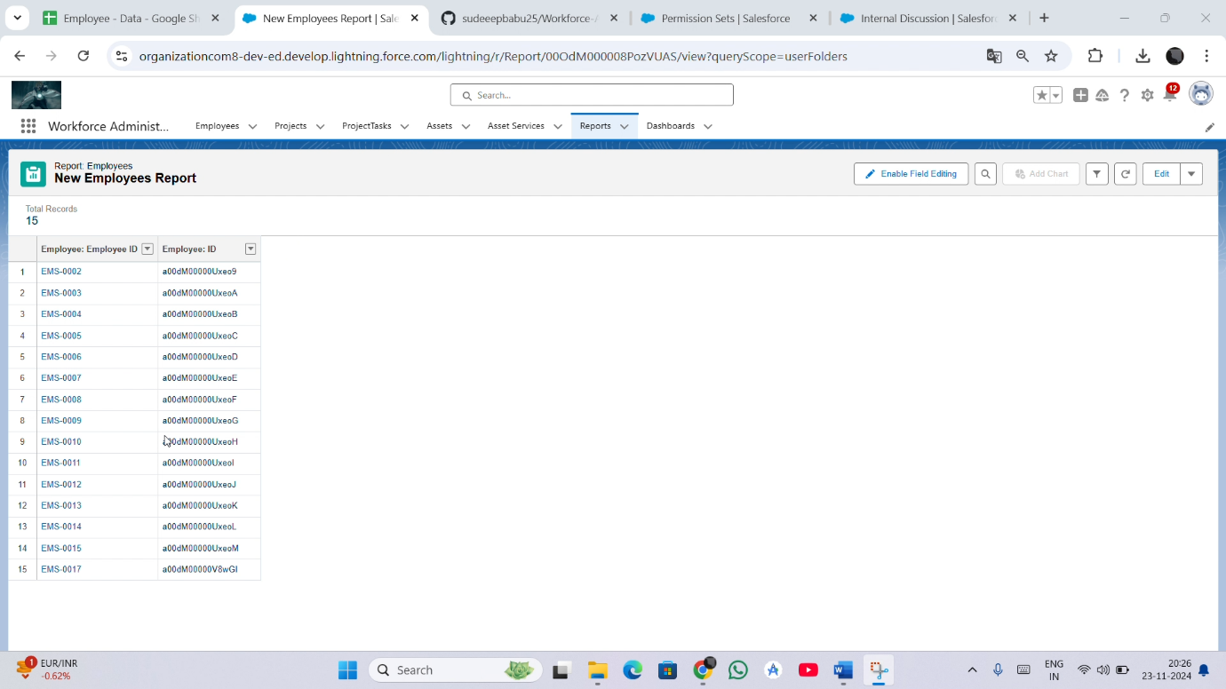

**Step 17: Dashboard**

**Activity 1: Create Dashboard**

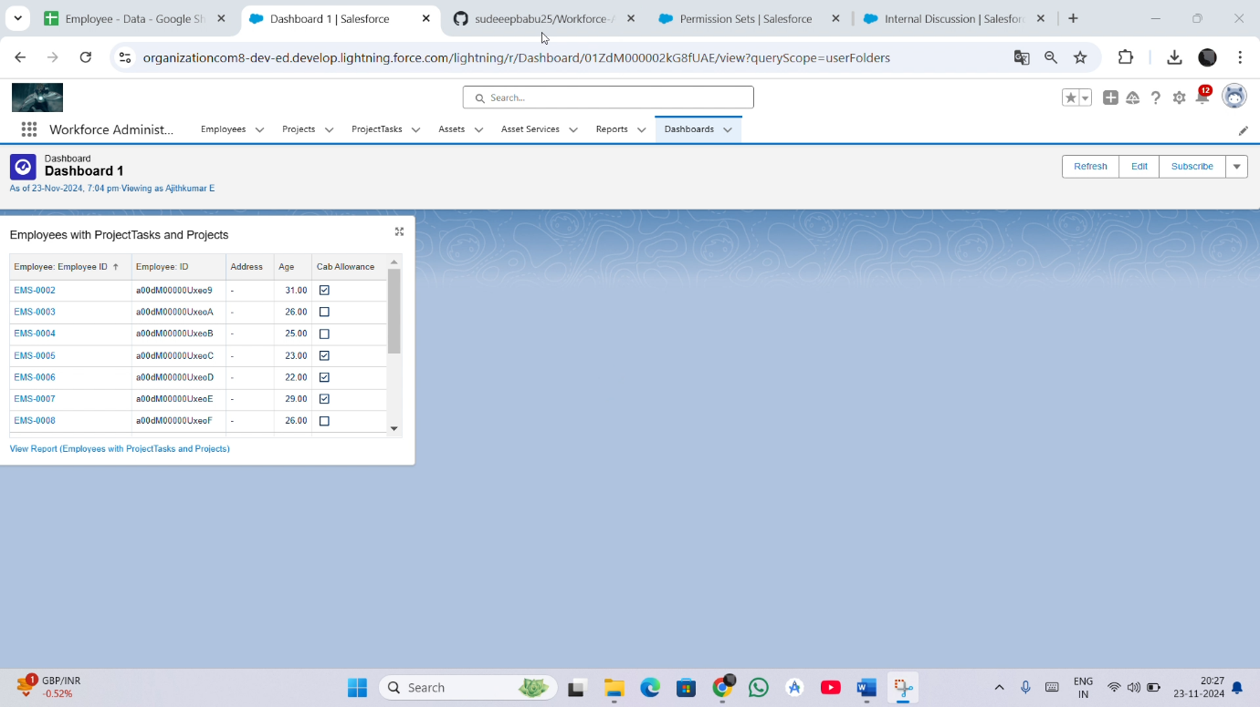

**Step 18: Approval processes**

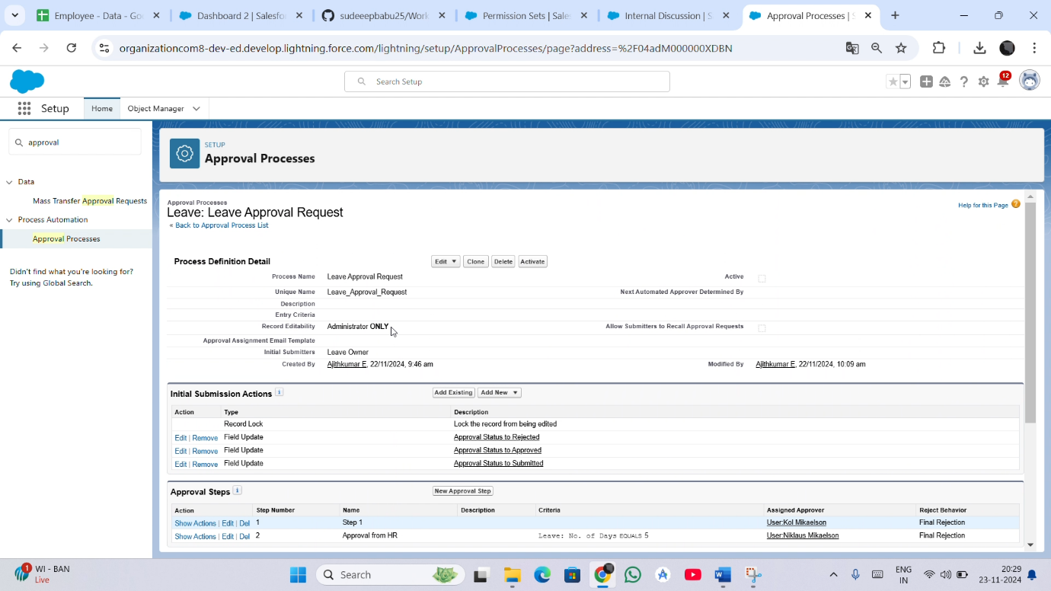

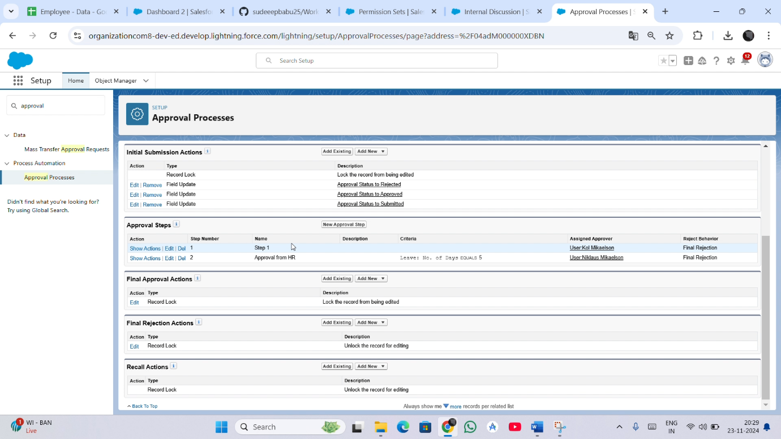

**Step 19: Apex Trigger**

**Activity 1 : Create and Test an Apex Trigger**

